
AKC Rules, Regulations, Policies and Guidelines are available on the American Kennel Club Web site, www.akc.org

OFFICIAL AMERICAN KENNEL CLUB AGILITY ENTRY FORM

AGREEMENT
ACT 1 and ACT II, ACT I and ACT II Jumpers. Event Registration at 8am, Briefing and Runs at 8:30am. Sunday, November 2, 2025 at AgileDogs, 37 S. Greenfield Road, Greenfield Center, NY 12833

$18 per round; $16 per round for 4-7 rounds of Standard and/or Jumpers; $120 for all 8 rounds (Standard + Jumpers)

Preregistration and day of registration accepted. Please mail preregistration by October 27, 2025 with check made out to AgileDogs to:
Trisha Stall, 37 S. Greenfield Road, Greenfield Center, NY 12833
I certify that I am the actual owner of the dog, or that I am the duly authorized agent of the actual owner whose name I have entered. In consideration of the acceptance of this entry, I (we) agree to abide by the rules and regulations of The American Kennel Club in effect at the time of this event, and any additional rules and regulations published for this event and any decision made in accord with them and further agree to be bound by this Agreement. I (we) agree that the club or ACT Evaluator, holding this event has the right to refuse this entry for cause which the club or ACT Evaluator shall deem sufficient. I (we) certify and represent that the dog entered is not a hazard to persons or other dogs. In consideration of the acceptance of this entry and of the holding of this event and of the opportunity to have the dog judged and to win prizes, ribbons, or trophies, I (we) agree to hold the AKC, the event-giving club, their members, directors, governors, officers, agents, superintendents, event secretary and the owner and/or lessor of the premises and any provider of services that are necessary to hold this event and any employees or volunteers of the aforementioned parties, and any AKC approved judge or ACT Evaluator, judging at this event, harmless from any claim for loss or injury which may be alleged to have been caused directly or indirectly to any person or thing by the act of this dog while in or about the event premises or grounds or near any entrance thereto, and I (we) personally assume all responsibility and liability for any such claim; and I (we) further agree to hold the aforementioned parties harmless from any claim for loss, injury or damage to this dog. Additionally, I (we) hereby assume the sole responsibility for and agree to indemnify, defend and save the aforementioned parties harmless from any and all loss and expense (including legal fees) by reason of the liability imposed by law upon any of the aforementioned parties for damage because of bodily injuries, including death at any time resulting therefrom, sustained by any person or persons, including myself (ourselves), or on account of damage to property, arising out of or in consequence of my (our) participation in this event, however such, injuries, death or property damage may be caused, and whether or not the same may have been caused or may be alleged to have been caused by the negligence of the aforementioned parties or any of their employees, agents, or any other person. I (WE) AGREE THAT ANY CAUSE OF ACTION, CONTROVERSY OR CLAIM ARISING OUT OF OR RELATED TO THE ENTRY, EXHIBITION OR ATTENDANCE AT THE EVENT BETWEEN THE AKC AND THE EVENT-GIVING CLUB (UNLESS OTHERWISE STATED IN THIS PREMIUM LIST) or ACT EVALUATOR AND MYSELF (OURSELVES) OR AS TO THE CONSTRUCTION, INTERPRETATION AND EFFECT OF THIS AGREEMENT SHALL BE SETTLED BY ARBITRATION PURSUANT TO THE APPLICABLE RULES OF THE AMERICAN ARBITRATION ASSOCIATION. HOWEVER, PRIOR TO ARBITRATION ALL APPLICABLE AKC BYLAWS, RULES, REGULATIONS AND PROCEDURES MUST FIRST BE FOLLOWED AS SET FORTH IN THE AKC CHARTER AND BYLAWS, RULES, REGULATIONS, PUBLISHED POLICIES AND GUIDELINES.
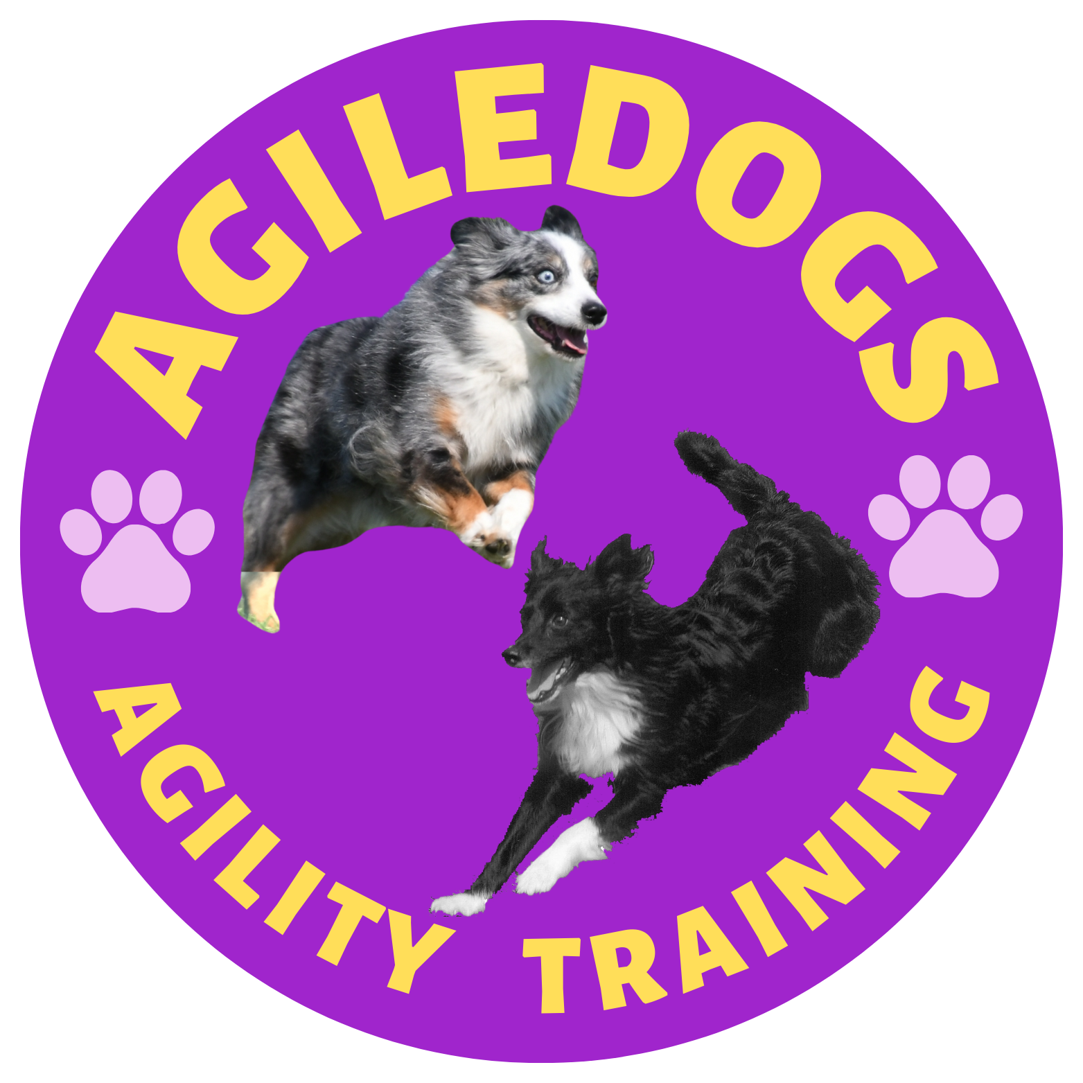
Agility Course Test (ACT)
Check one jump height
4”
8”
12”
16”
20”
24”
Checkmark one or both rounds of a class level (ACT 1 or ACT 2)
ACT 1 (Round 1) (O
ACT 2 (Round 1)
ACT 1 (Round 2)
ACT 2 (Round 2)
SEX
VARIETY
IMPORTANT: CAREFULLY READ INSTRUCTIONS BEFORE FILLING OUT!
ENTRY FEE ENCLOSED
$
BREED
HEIGHT AT WITHERS
CALL NAME

INSTRUCTIONS
ACT 1 Jumpers (Round 1)
ACT 2 Jumpers (Round 1)

Dogs may be entered in any jump height. There is no Regular or Preferred distinction at AKC’s ACT events.
ACT 1 Jumpers (Round 2)
ACT 2 Jumpers (Round 2)

In order to acquire the ACT1 or ACT2, or ACT1-Jumpers or ACT2-Jumpers title certificate and have the title added to a dog’s record, the dog must be registered/listed with the American Kennel Club. AKC Canine PartnersSM applications may be accepted at the event and submitted to AKC with the event’s results.

Dogs that are not AKC registered/listed may be registered at a later date and receive their ACT title at that time.

AKC® NAME

Dogs listed in the AKC Canine PartnersSM program should be listed as All American Dog and must include their AKC number on the entry form and check the AKC No. box.

Junior Handlers should enter their Junior Handler Number on the front of this form. Should you not have your Junior Handler number, it may be obtained from the American Kennel Club (919) 233-9767. If the Junior Handler is not the owner of the dog identified on the face of this form, what is the relationship of the Junior Handler to the Owner?
AKC NO.
Enter Complete Registration # below (If applicable for)
DATE OF BIRTH
PAL/ILP NO.

FOREIGN REG. NO.
Pending
PLACE OF BIRTH (List Country)

BREEDER

SIRE

DAM
SIGNATURE of owner or his agent duly authorized to make this entry.

SIGN HERE X

Telephone Number: ACTUAL OWNERS

Email Address: New Email
OWNERS ADDRESS
NEW ADDRESS

CITY

State Zipcode + 4
In Case of Emergency - Name: Phone #:

HANDLER (Junior Handler see back)
If Junior Handler, Please enter # Below
FEE ENCLOSED

EXHIBITOR / OWNER MUST READ AND SIGN THE REVERSE SIDE OF THIS FORM.

AEAGL2 (02/16) ACT v1.0

