Dog Training Classes

(continuing students only)
September session 2025

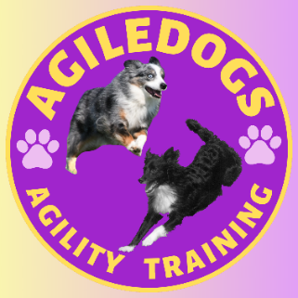
AgileDogs, 37 S Greenfield Rd, Greenfield Center, NY 12833

518-237-7712 or 518-331-7814

http://agiledogs.net

It’s spring! We will be holding some classes outside, weather permitting, for this session. All classes are 6 weeks long and start the week of September 1st unless otherwise noted. We need to receive your registration to guarantee your spot. Please fill out a separate form for each dog. Multiple dog discounts apply to all classes! If you enter either the same or different dog from the same household in more than one class take $15 off the second dog’s registration. Anyone who refers a new student to us who ends up taking a class will receive $25 off their next session (referring person must mention new student to get discount).

Dog’s Name | Day/Time | Class | Instructor | Price | Venmo or PayPal?
 |  |  |  |  | V PP
 |  |  |  |  | V PP
 |  |  |  |  | V PP

To sign up for any class(es), fill in the class(es) you wish to take above, make a check out to AgileDogs and return it to the address above with this form filled out. Cost is $100 for all 6 week classes, and $18 per week for drop in classes.
NEW! You may pay via PayPal or Venmo. There is a 3% convenience fee (for a single dog, a 6 week session is $103; for second dog in same household add $87). For PayPal and Venmo, email address is agiledogs@outlook.com, or phone # 518-331-7814.
If you choose this option please still mail or email me the registration form and circle venmo/paypal as payment type above.

Your Name: | Phone Number (if changed): | Email (if changed):
Address (if changed):
1st Dog’s Name: | Breed:
2nd Dog’s Name: | Breed:
3rd Dog’s Name: | Breed:

For office use only: Pd Amt: $_______ Date _____________ Check # ___________ Received by: _____________

Current classes:
Monday: 5:00 Intermediate Scentwork – Starts 9/8 Rebecca
Drop in Classes contact info (Intermediate Agility or above, Agility Games, Intermediate Scentwork or above, Intermediate Rally Obedience):

Bob 518-237-7712
Diane P 518-532-4222
Trisha 518-331-7814
Julie 518-885-5299
Diane L 518-369-4992
Rebecca 518-928-0829
6:15 Novice Competition Agility - Starts 9/8 Bob/Trisha
6:30 Advanced Scentwork - Starts 9/8 Rebecca
7:30 Beyond Beginners Agility - Starts 9/8 Bob/Trisha
Tuesday: 10:00 Intermediate Scentwork Bob
11:00 Intermediate Agility Bob
6:15 Intro to Scentwork Trisha/Bob
6:15 Intermediate Agility Trisha/Bob
7:30 Agility 201 Trisha/Bob
Wednesday 10:00 Competition Agility Bob
11:00 Intermediate Agility Bob
5:30 Intermediate Agility Bob/Trisha
4:30 Advanced Scentwork - Starts 8/20 Diane L
6:00 Intermediate Scentwork - Starts 8/20 Diane L
7:00 Agility 101 Trisha
Thursday 6:30 Jumping Foundations Trisha/Bob
7:30 Intermediate Rally Obedience Julie

