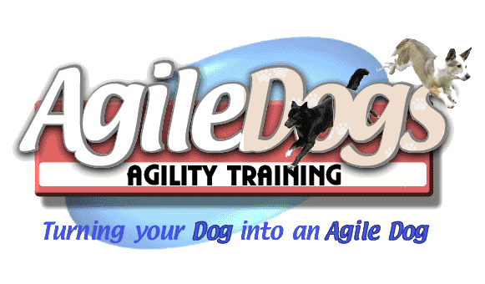
AgileDogs Summer Camp July 28-29 2018
Sugar Bush Farm, Stephentown NY
Terri Cesarek and Lori Kline

Who can attend? Any dog currently competing at any level, in any venue, or ready to compete can attend this camp. Dogs need to be comfortable on all equipment, but do not need to be proficient on all. Email Bob Domfort with questions at bob@agiledogs.net .
Who are the instructors? We are pleased to have Terri and Lori coming to AgileDogs!! Please see pages 2-3 for their profiles.
What’s the cost? $375 for the Weekend. Limit 24 working Teams. A deposit of $100 (non-refundable) is required to guarantee a spot by May 30th, 2018. The balance of $275 is due by July 9th, 2018.
Can I audit? Yes! Audit fees are $100/day. All levels of experience are welcome to audit.
Can I work a second dog? You may only work one dog at a time. However, if you want to substitute a second dog working at a similar or higher level to your first dog, please contact us so we can approve the substitution.
Are cancellations allowed? For cancellations more than 4 weeks prior to the Camp, before 6/29/18, full refund is available. For cancellations less than 4 weeks prior to the workshop, fees will not be refunded unless we can fill your spot. Bitches in season and aggressive dogs are not allowed on the grounds. If you plan to attend with an intact bitch, you should plan ahead and arrange to have an alternate dog of similar skill level available to work. No refunds for bitches in season.

Registration Form – Terri and Lori Camp 2018

Name: ________________________ Address: __________________________________________________________

Phone Number: ________________________ Email Address: ______________________________________________

Dog’s Name: ____________ Breed(s): ____________________ Age: ______ M/F: __ Level competing at: __________

Dog’s Name: ____________ Breed(s): ____________________ Age: ______ M/F: __ Level competing at: __________

Full Day Working Spot _____ Auditor _____

Release form: I / we agree to hold Sugar Bush Farm and AgileDogs Agility Training, its members, directors, officers, agents, and the owner or lessor of the premises and any employees of the aforementioned parties, any sponsors of this event, harmless from any claim or loss or injury which may be alleged to have been caused directly or indirectly to any person or thing by the act of this dog or handler while in or upon the camp premises or grounds or near any entrance thereto, and I / we further agree to hold the aforementioned parties harmless from any claim or loss of this dog by disappearance, theft, death or otherwise, and from any claim for damage or injury to the dog, whether any claim be caused or alleged to be caused by the negligence of the hosts or any of the parties aforementioned, or by the negligence of any other person, or any other cause or causes. I / we hereby assume sole responsibility for and agree to indemnify and save the aforementioned parties harmless from any and all loss and expense (including legal fees) by reason of the liability imposed by law upon any of the aforementioned parties for damage because of bodily injuries, including death at any time resulting therefrom, sustained by any person or persons, including myself / ourselves or on account of damage to property, arising out of or in consequence of my / our participation in the Camp, howsoever such injuries, death or damage to property may be caused and whether or not the same may have been caused by negligence of the aforementioned parties or any of their employees or agents, or any other persons.

I/we testify that the dog(s) entered is (are) healthy and up to date on vaccinations. I/we certify that the dog(s) entered is (are) not dangerous to any person or other dog. By signing below, I/we agree to the disclaimer above.

Signature – Owner or Parent / Guardian if Minor Date

Send the lower half of this page in with a check/money order made payable to AgileDogs, and send it to: Bob Domfort, 22 Mazurki Court, Cohoes, NY 12047. There will be a $25 fee for returned checks.

For office use only: Pd Amt: $_______ Date _____________ Check # ___________ Received by: _____________
About the Instructor ~ Terri Cesarek
Terri became addicted to agility after experiencing the confidence it gave her All-American Mandy, a rescue dog found wandering on a highway. Wanting to help her shy pup, Terri began obedience classes in search of a way to help Mandy overcome her fears. This was the beginning of a perpetual interest in canine behavior that has developed through experience and a natural gift in reading dogs. In 1993 while competing at an obedience match Terri and Mandy were introduced to agility when a local group presented a demo. Afterward the group let spectators try some of the equipment. That was it, they were immediately hooked! Together Terri and Mandy learned how much fun the sport of agility could be. It was the start of an amazing journey.
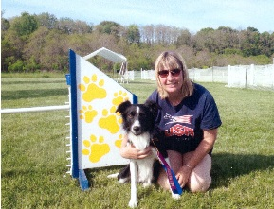
Since then she has trained three other dogs – Chase!, Shine and Rise to their USDAA Agility Dog Championships along with competing with them nationally. Each of them has taught Terri about consistency and good foundation training. The journey has continued with her youngest dog, Crest who will ultimately be her best teacher as she learns to look outside of the box to help Crest deal with life. “Crest is an amazing athlete and can perform so well in some environments, but the competition environment is not yet always a good one for him. He is not a one size fits all kind of dog as far as training methods go and I am grateful for all he teaches me every day. He has pushed me to look outside of the box in my training which has greatly enhanced my teaching. They say you get the dog you need... I needed a little bit of magic in my life.”
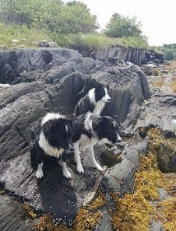
Terri’s dogs all are wonderful teachers constantly reminding her how important the relationship between dog and handler is not just for agility, but for life. It is a key element in her training, as she helps her students realize the joy of training their own canine companions. Her approach to training is not a cookie-cutter method as she will evaluate each team looking to bring out their very best. She enjoys helping each dog and handler strengthen their relationship by learning to work as a team going on to achieve success at whatever level they wish to pursue. Whether an individual wants to compete at the national level or play in their backyard, her focus is on a solid foundation which is a building block necessary for great teamwork. Coaching people on finding a clear, consistent handling method to provide the best connection with their dog on course is Terri’s goal in working with each dog and handler. She keeps training fun for both the handlers and their dogs establishing an environment that cultivates learning.
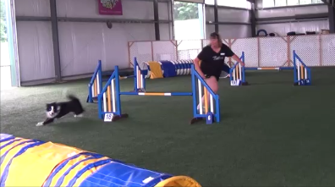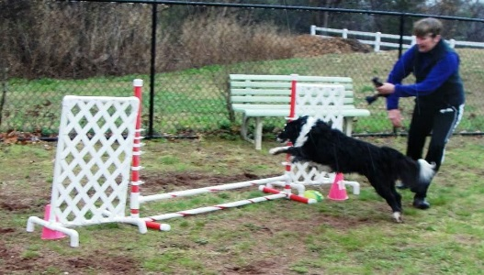

About the Instructor ~ Lori Kline
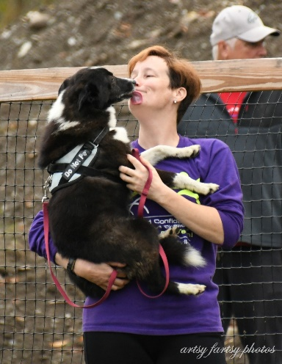
Lori has been competing in agility since the late 1990s at the local, regional and national levels.
Her dogs have taught her lessons on being a good observer of body language and to think outside the box when it comes to accomplishing goals. Success comes from trying new things and building the dog's drive and focus through play.
She is known for running quirky dogs or dogs with “issues” and has experience dealing with reactivity and aggression as well as ring nerves and dogs with less drive, or over the top drive. Lori has demonstrated the ability to compete successfully and win with the moderate to slow speed dog, the reactive dog and the fearful dog by focusing on each animal’s strengths and using that to full advantage.
She is a follower of Susan Garrett and the Say Yes philosophy of dog training and Handling 360 system.

